Editing Peak Audax website
Table of Contents
Login 1
Editing 3
Adding Photos 7

Login
https://peakaudax.co.uk/wp-login.php
Login using username / password
Ticking the Remember Me
Will log you in automatically when you use
https://peakaudax.co.uk/wp-login.php or https://peakaudax.co.uk/ Note clearing history will forget the automatic login
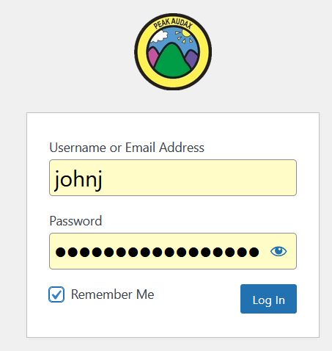

Do not worry about this page as you will probably not need to use it.
Either click the Home icon next to Peak Audax CTC Then Click Visit Site
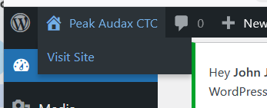

Or if you have clicked Remember Me Just close the window and use the normal URL
https://peakaudax.co.uk/
The Remember Me and the standard https://peakaudax.co.uk/ is simplest easy option for most users. The next time you use https://peakaudax.co.uk/ you are automatically logged in

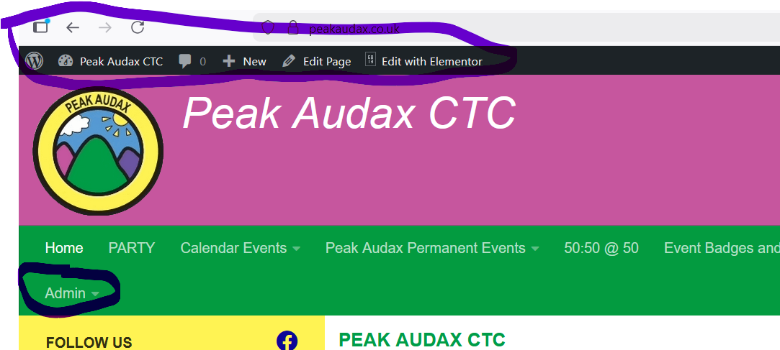
If you are logged in. You will see a black admin menu bar at the top and extra menu items on the main menu bar.

Editing
To practice Editing
A test page has been setup with Chirk badges and dummy Event details based on the Chirk event. Text is from a reunion page
Ensure the browser is logged into Peak Audax as above. Open page https://peakaudax.co.uk/test/
Click the Edit with Elementor on the black menu bar.
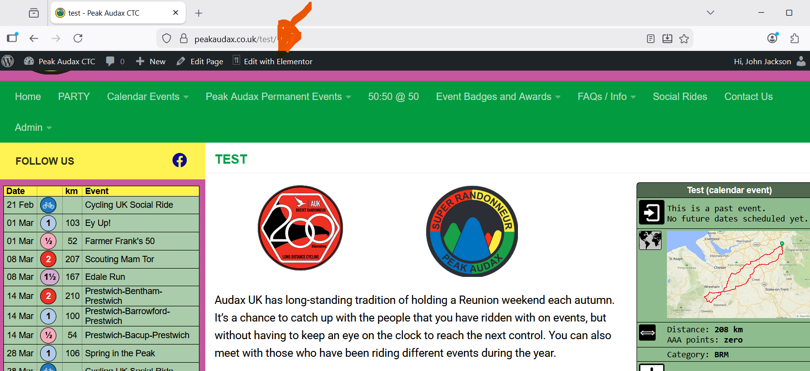
After a short delay the editor will open

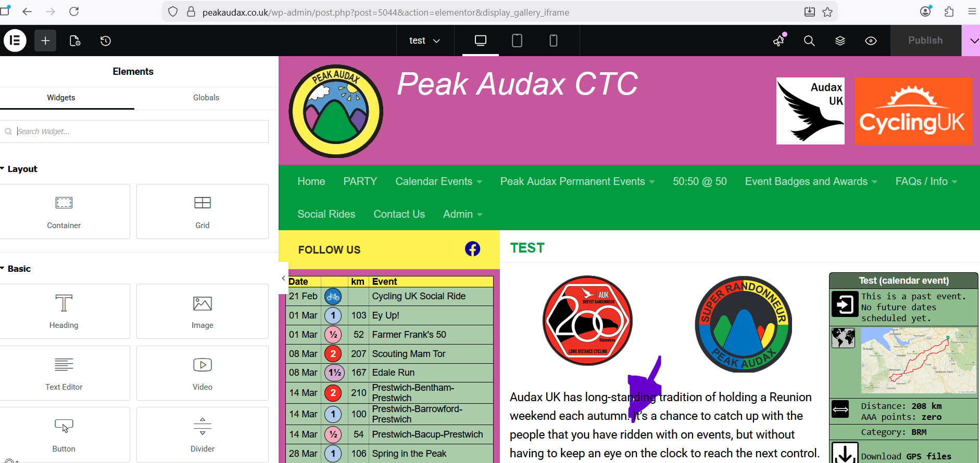
Click on the text area (indicated by blue arrow) to open the text editor
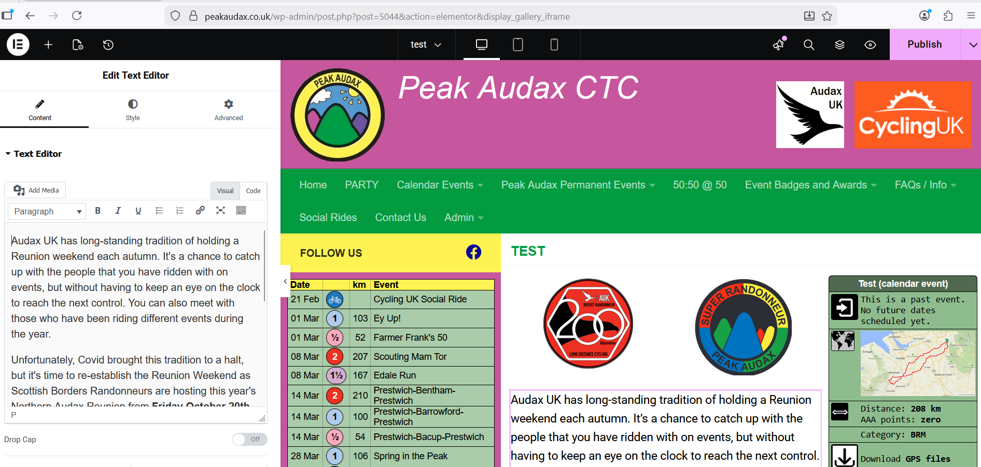
The edit window appears on the left
This can be resized by dragging the right side of White “Edit Text Window”
Edit the text in the left window. The right window will show changes
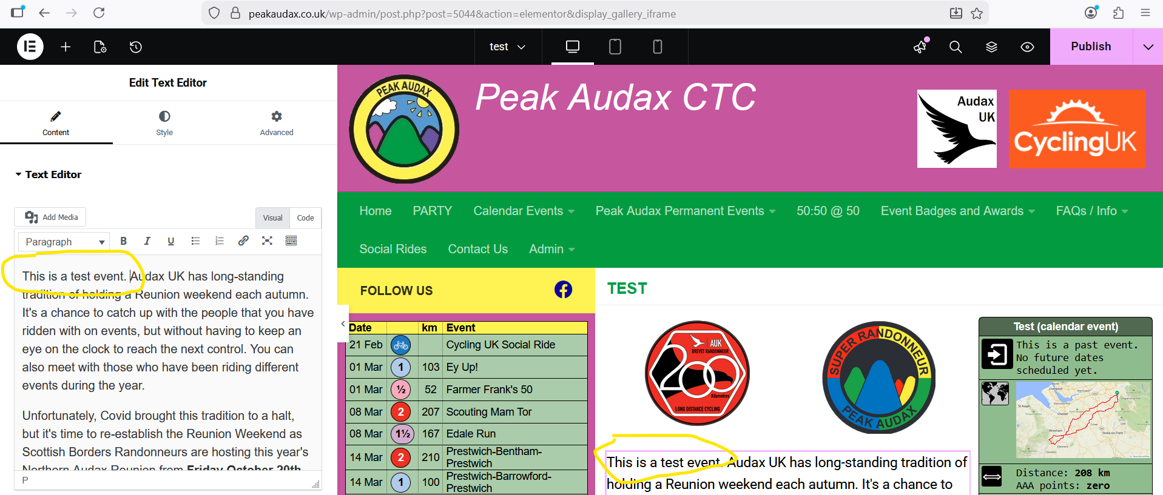
The picture below shows I have edited the text to add.
This is a test event.
The edit on the left is shown on the right window
The editor gives you basic formatting options. Hovering over an icon gives a tool tip Eg Paste as Text
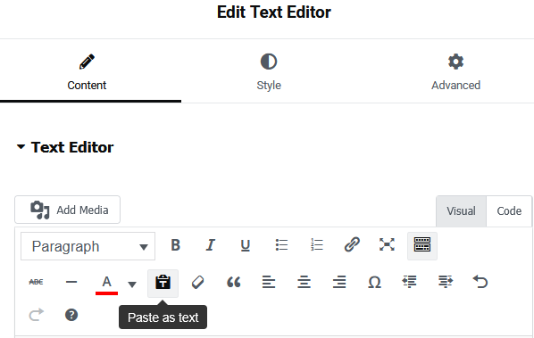
Note To show the second and third row of Icons click the Toolbar Toggle icon
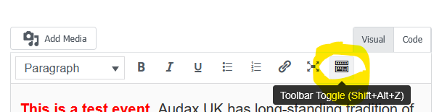

To undo a change use the undo icon or from the keyboard Ctrl + z
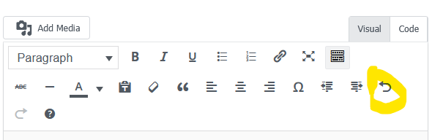

When you are happy with your changes you can preview the page
Click the eye icon newt to publish
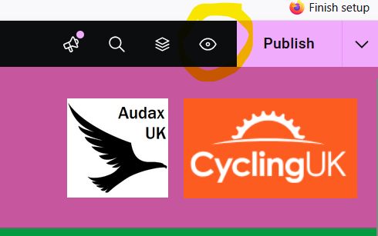

This will show the page in a new tab. Note:- The preview page is not update if you make another change , you need to click the eye icon again.
When you are happy click Publish The Purple background will change to dark grey.
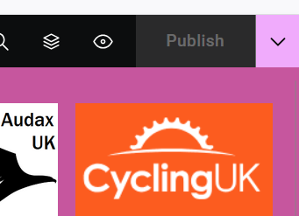

If you wish to abandon the changes before publishing just close the tab or browser
Click Leave Page to avoid saving changes.
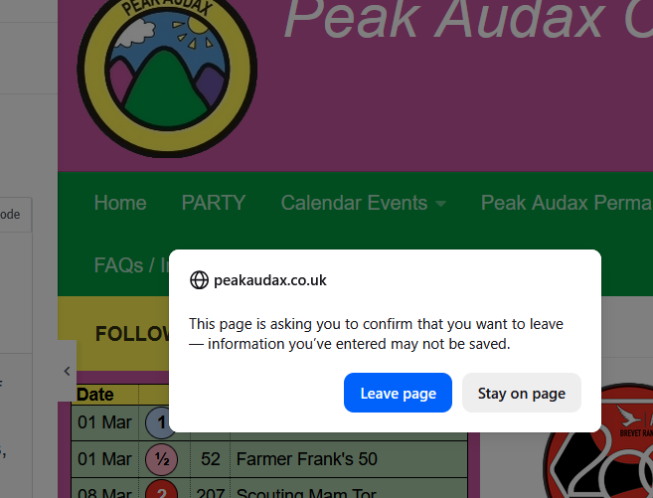

Edit Warning
Please do not edit or delete text in [] brackets eg
[pa-event-info action="eventBadge"]
This is used to run code to insert event badges, side bars, list of events etc
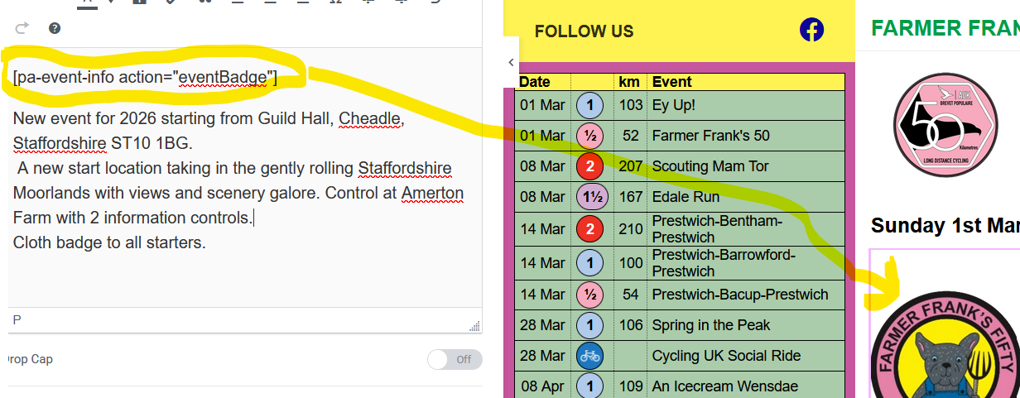

Adding Photos
To insert a photo. Click in the text where you want to insert the photo. Click Add Media
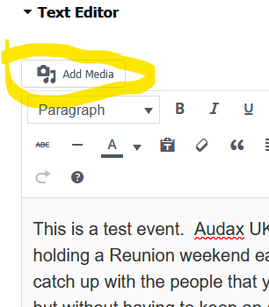

Click the image it will show a Blue tick then click the Insert into post button
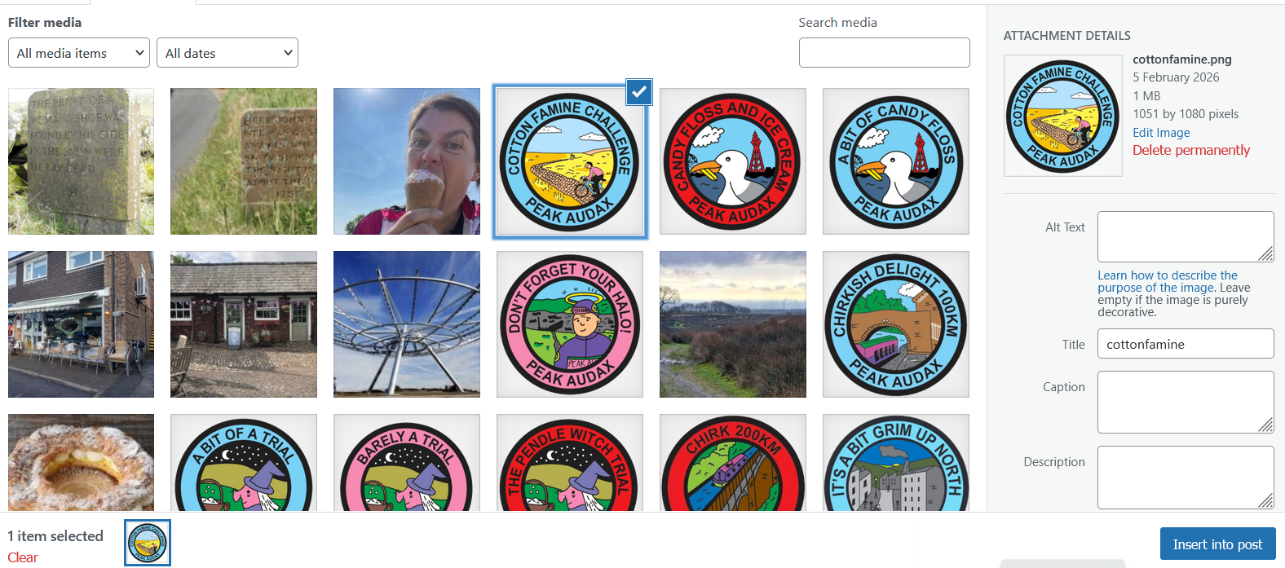
The image is now inserted
Click on the image a Menu bar is displayed.
Click the pencil icon
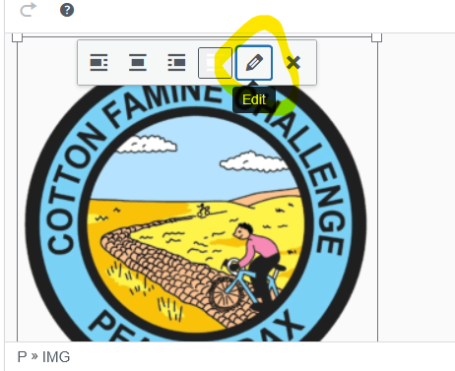

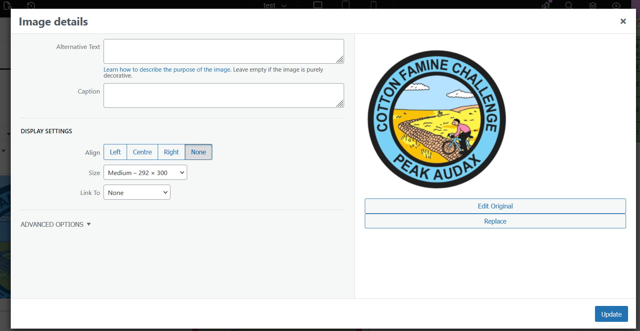
On the Edit screen You can put the image to the Left or Right of the text. If you select centre the text will be above and below the image. You can select also change the image size. You can also add a caption
Click update to make the image changes. You will need to click publish to make the change on to live page. If the changes are not right just click the image and click the Edit icon again.
The caption does not give a true view of the final result You will need to use the eye icon to preview the page
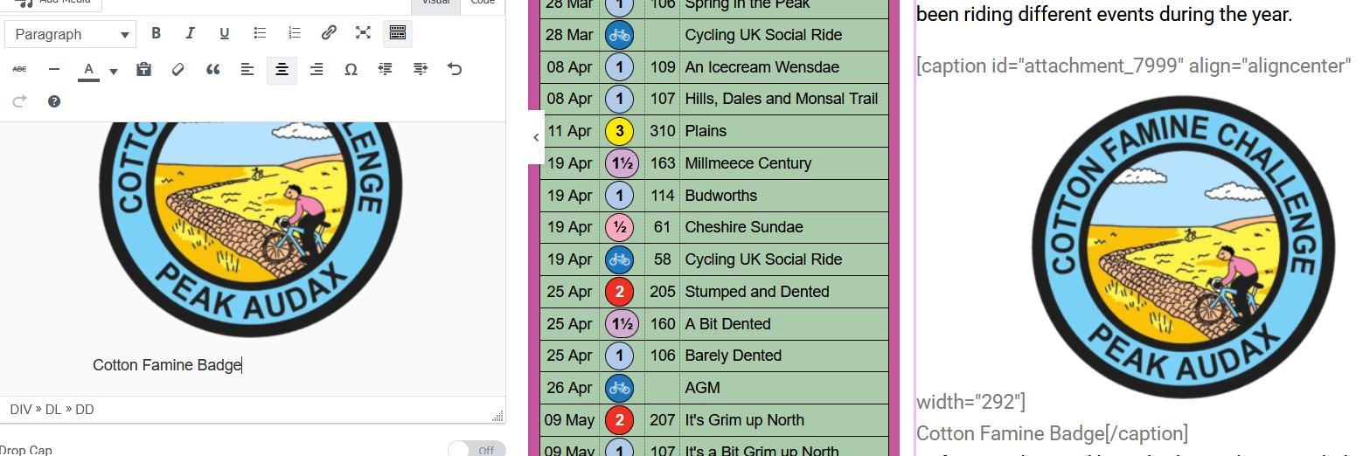
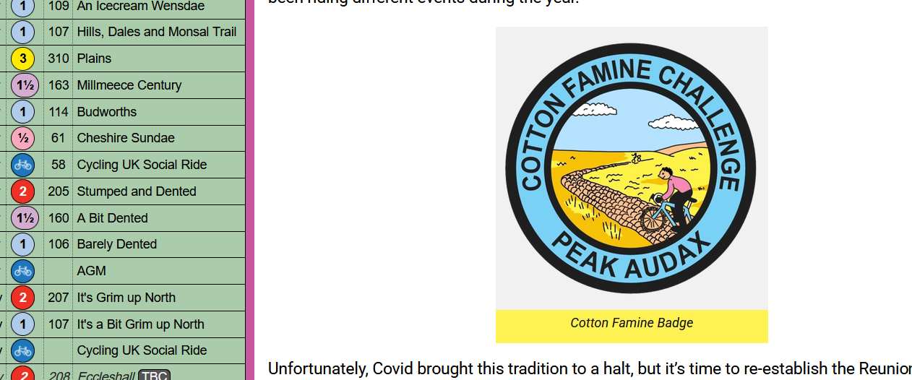

If you need to add a new image rather than clicking an existing image Click the Upload files tab and upload from your computer.
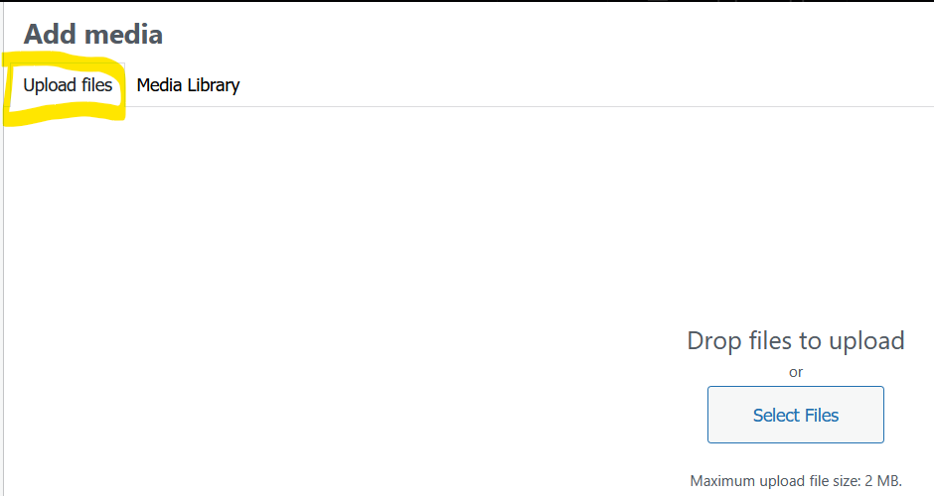

Page Recovery
Don’t panic Make sure you are in editor mode and click in the text area.
click the History icon top left.
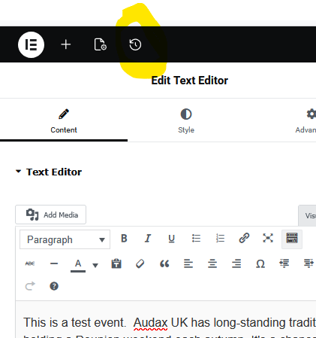

The Actions Tab will allow you to go back to a point in time since you opened the editor.
The Revisions allow you to go back to a Date / Time
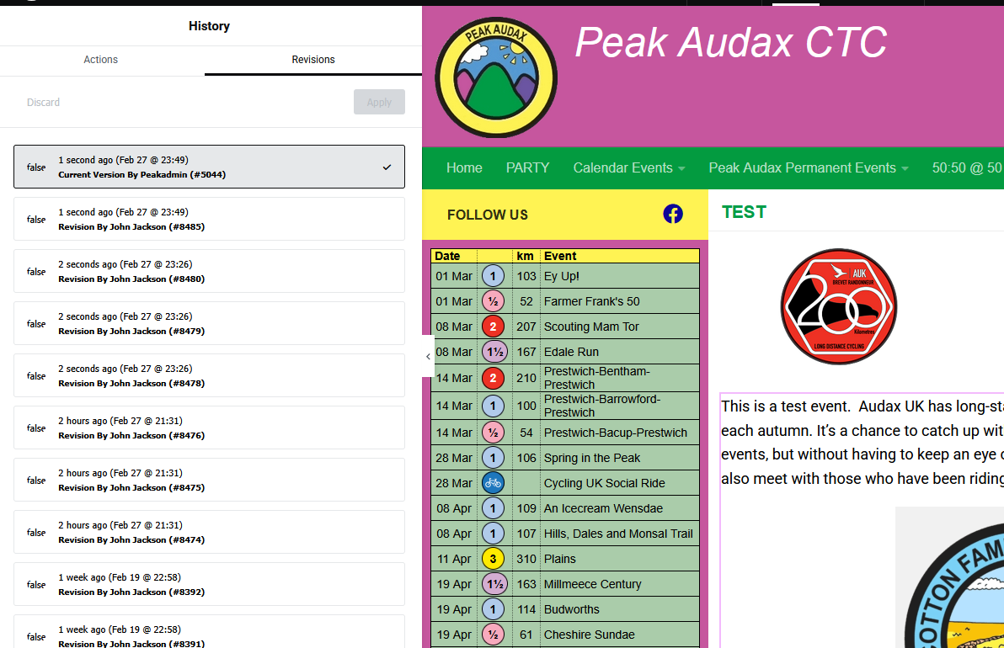
Clicking a Revision reverts to that time/date
For example I have gone back to the start of tonight’s editing. This has undone all the changes I made adding the image. Remember to click publish to update the website.
